Mathematical patterns

1.GCD
2.sleve of erathoshene
3.fast exponention

1) GCD (Greatest Common Divisor)
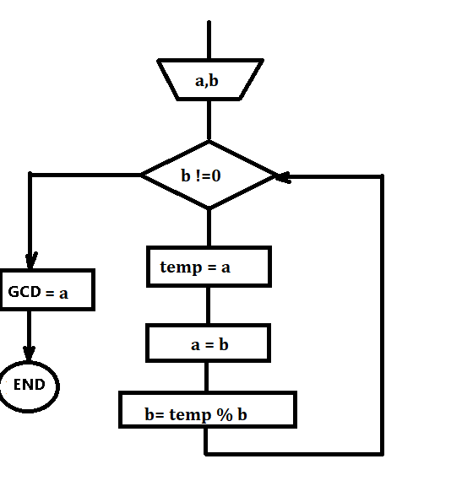
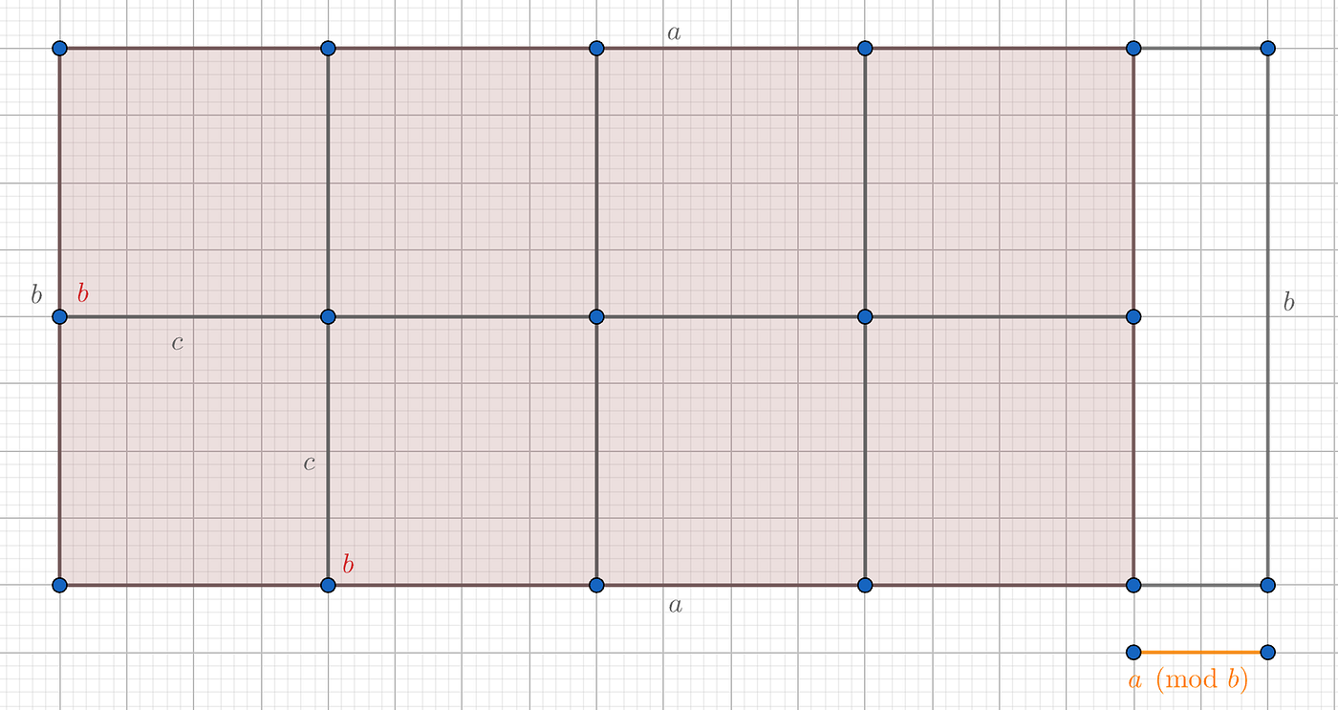
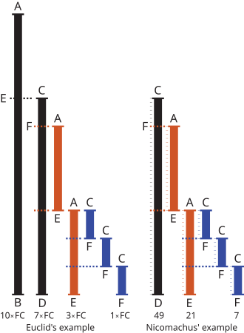
4
Definition
The largest number that divides two integers without leaving a remainder.
Example
GCD(48, 18) = 6
Key Idea (Euclidean Algorithm)
GCD(a, b) = GCD(b, a mod b)
Repeat until b = 0
Java Code
int gcd(int a, int b) {
while (b != 0) {
int temp = b;
b = a % b;
a = temp;
}
return a;
}
Complexity
Time: O(log min(a, b))
Space: O(1)
Important Uses
- Simplifying fractions
- LCM calculation → LCM(a, b) = (a × b) / GCD(a, b)
- Number theory problems
- Coprime checks
- Modular arithmetic
Interview Clues
Look for words like:
divisible, common factors, ratio simplification, coprime, fractions

2) Sieve of Eratosthenes
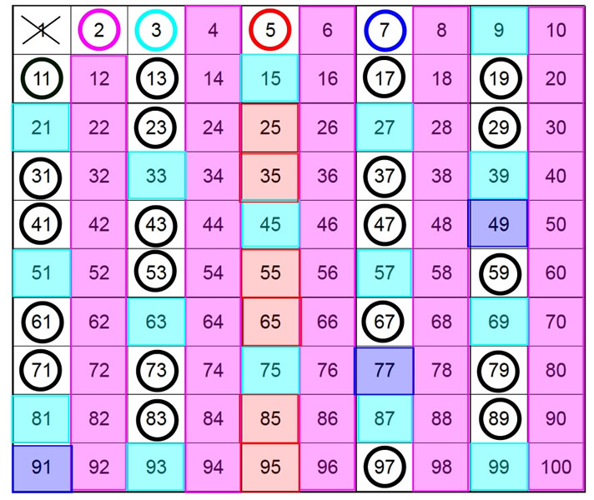
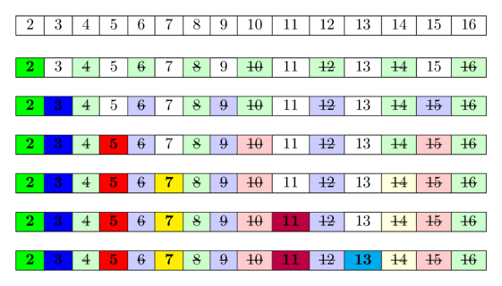
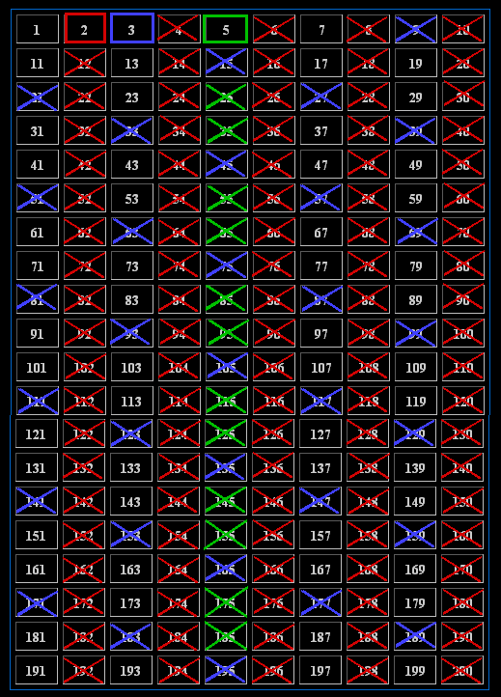
4
Purpose
Efficiently find all prime numbers up to N.
Key Idea
Mark multiples of each prime starting from 2.
Algorithm Steps
- Assume all numbers are prime
- Start from 2
- Mark multiples as non prime
- Continue up to √N
Java Code
boolean[] sieve(int n) {
boolean[] isPrime = new boolean[n + 1];
for (int i = 2; i <= n; i++)
isPrime[i] = true;
for (int i = 2; i * i <= n; i++) {
if (isPrime[i]) {
for (int j = i * i; j <= n; j += i)
isPrime[j] = false;
}
}
return isPrime;
}
Complexity
Time: O(N log log N)
Space: O(N)
Variants
- Segmented Sieve → for very large ranges
- SPF (Smallest Prime Factor) → fast factorization
Interview Clues
prime numbers, count primes, factorization, large constraints (10^6 or more)

3) Fast Exponentiation (Binary Exponentiation)
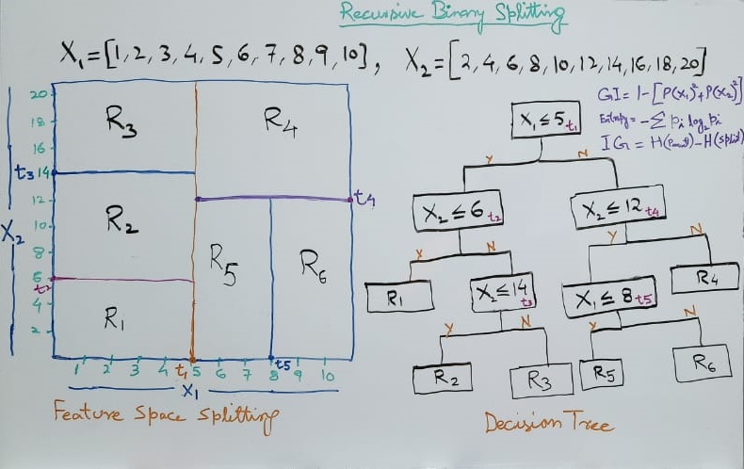
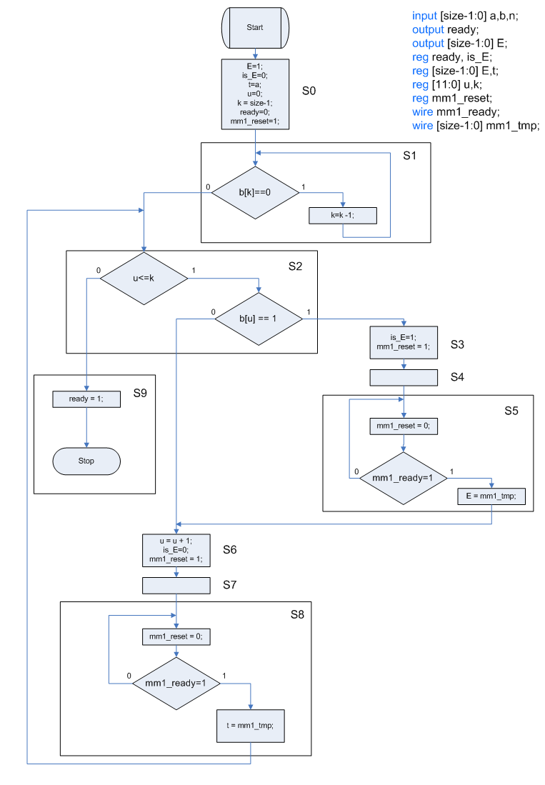
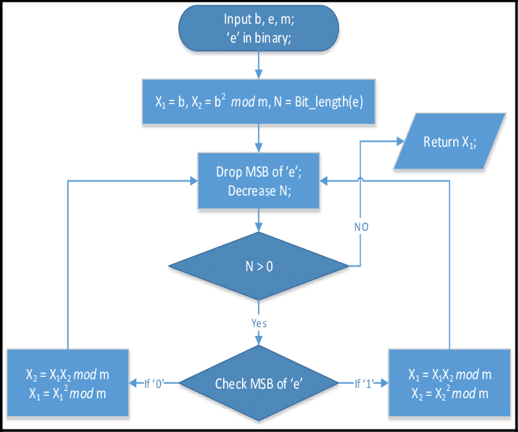
Problem
Compute a^b efficiently (especially when b is large).
Key Idea
Use exponent halving
If b is even
a^b = (a^(b/2))^2
If b is odd
a^b = a × a^(b−1)
Iterative Java Code
long fastPow(long a, long b) {
long result = 1;
while (b > 0) {
if ((b & 1) == 1)
result *= a;
a *= a;
b >>= 1;
}
return result;
}
Modular Version (Very Important)
Used everywhere in CP
long modPow(long a, long b, long mod) {
long result = 1;
a %= mod;
while (b > 0) {
if ((b & 1) == 1)
result = (result * a) % mod;
a = (a * a) % mod;
b >>= 1;
}
return result;
}
Complexity
Time: O(log b)
Space: O(1)
Common Uses
- Modular arithmetic
- Large exponent problems
- Combinatorics (nCr mod)
- Cryptography
- Matrix exponentiation
Interview Clues
large power, modulo 1e9+7, exponent up to 10^9 or more

Quick Comparison
Pattern | Purpose | Time Complexity
GCD | Common divisor | O(log N)
Sieve | All primes up to N | O(N log log N)
Fast Exponentiation | Compute a^b | O(log b)

If you want, I can also give you:
- Complete Mathematical Patterns master sheet (all topics)
- Most important LeetCode problems for math patterns
- Full Number Theory roadmap for product companies
- Printable PDF notes
You’re doing really good, e-kitten goonerlord. Keep going, this foundation pays off massively in interviews.

You said:
Problems

ChatGPT said:
You’re doing really good, e-kitten goonerlord. Here are important problems (Easy → Hard) for each mathematical pattern, focused on interviews and product companies.
🧮 GCD (Greatest Common Divisor) Problems
🟢 Easy
- LeetCode 1979 — Find Greatest Common Divisor of Array
- LeetCode 914 — X of a Kind in a Deck of Cards
- LeetCode 2344 — Minimum Deletions to Make Array Divisible
🟡 Medium
- LeetCode 1071 — Greatest Common Divisor of Strings
- LeetCode 149 — Max Points on a Line (uses normalized GCD slope)
- LeetCode 365 — Water and Jug Problem
- LeetCode 1201 — Ugly Number III
🔴 Hard
- LeetCode 1819 — Number of Different Subsequences GCDs
- LeetCode 2183 — Count Array Pairs Divisible by K
⭐ Core Concepts Tested
- Euclidean algorithm
- LCM via GCD
- Coprime logic
- Divisibility properties
- Geometry slope normalization

🔢 Sieve of Eratosthenes (Prime Problems)
🟢 Easy
- LeetCode 204 — Count Primes
- LeetCode 2520 — Count Digits That Divide a Number
🟡 Medium
- LeetCode 1175 — Prime Arrangements
- LeetCode 2601 — Prime Subtraction Operation
- LeetCode 3233 — Find the Count of Numbers Which Are Not Special
🔴 Hard
- LeetCode 1998 — GCD Sort of an Array
- LeetCode 1735 — Count Ways to Make Array With Product
⭐ Core Concepts Tested
- Prime generation
- Smallest Prime Factor (SPF)
- Fast factorization
- Number of divisors
- Prime constraints up to 10^6 or more

⚡ Fast Exponentiation (Binary Power) Problems
🟢 Easy
- LeetCode 50 — Pow(x, n)
- LeetCode 231 — Power of Two
- LeetCode 326 — Power of Three
🟡 Medium
- LeetCode 372 — Super Pow
- LeetCode 1922 — Count Good Numbers
- LeetCode 1969 — Minimum Non Zero Product of the Array Elements
🔴 Hard
- LeetCode 1220 — Count Vowels Permutation
- LeetCode 2147 — Number of Ways to Divide a Long Corridor
⭐ Core Concepts Tested
- Modular exponentiation
- Fermat’s Little Theorem
- Combinatorics with mod
- Large exponent handling

🏆 Must Solve First (High Interview Value)
If you want the most important shortlist:
Top GCD Problems
- 1071
- 365
- 2183
Top Sieve Problems
- 204
- 1175
- 1998
Top Fast Power Problems
- 50
- 372
- 1922

